* 1. **All** fields are mandatory

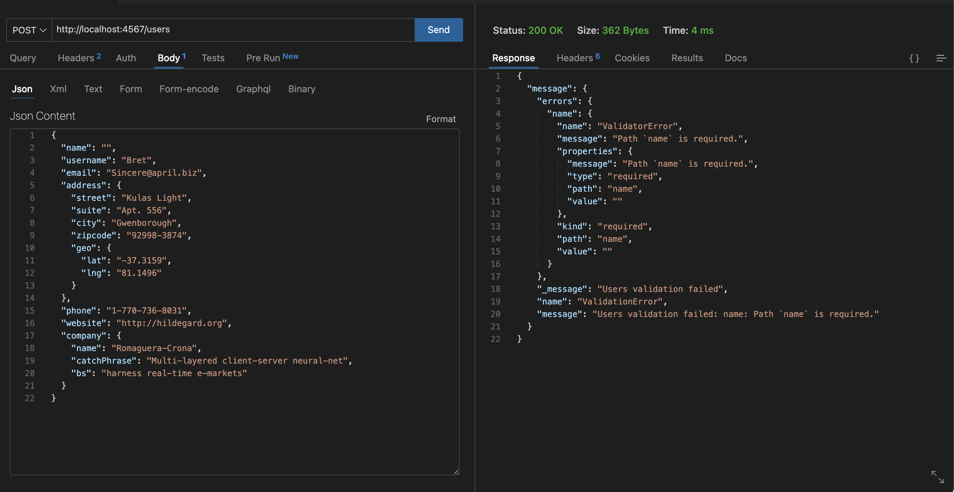

* 1. **Username** field must have length >=4

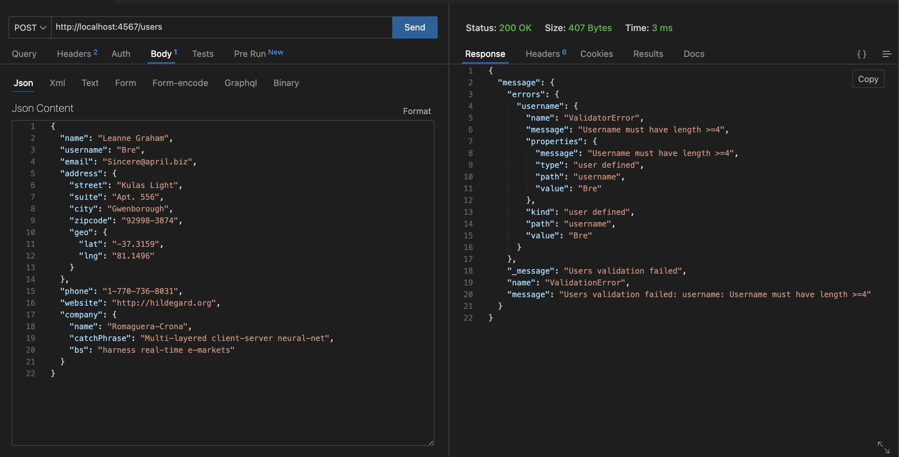

* 1. Allow only valid **email** address

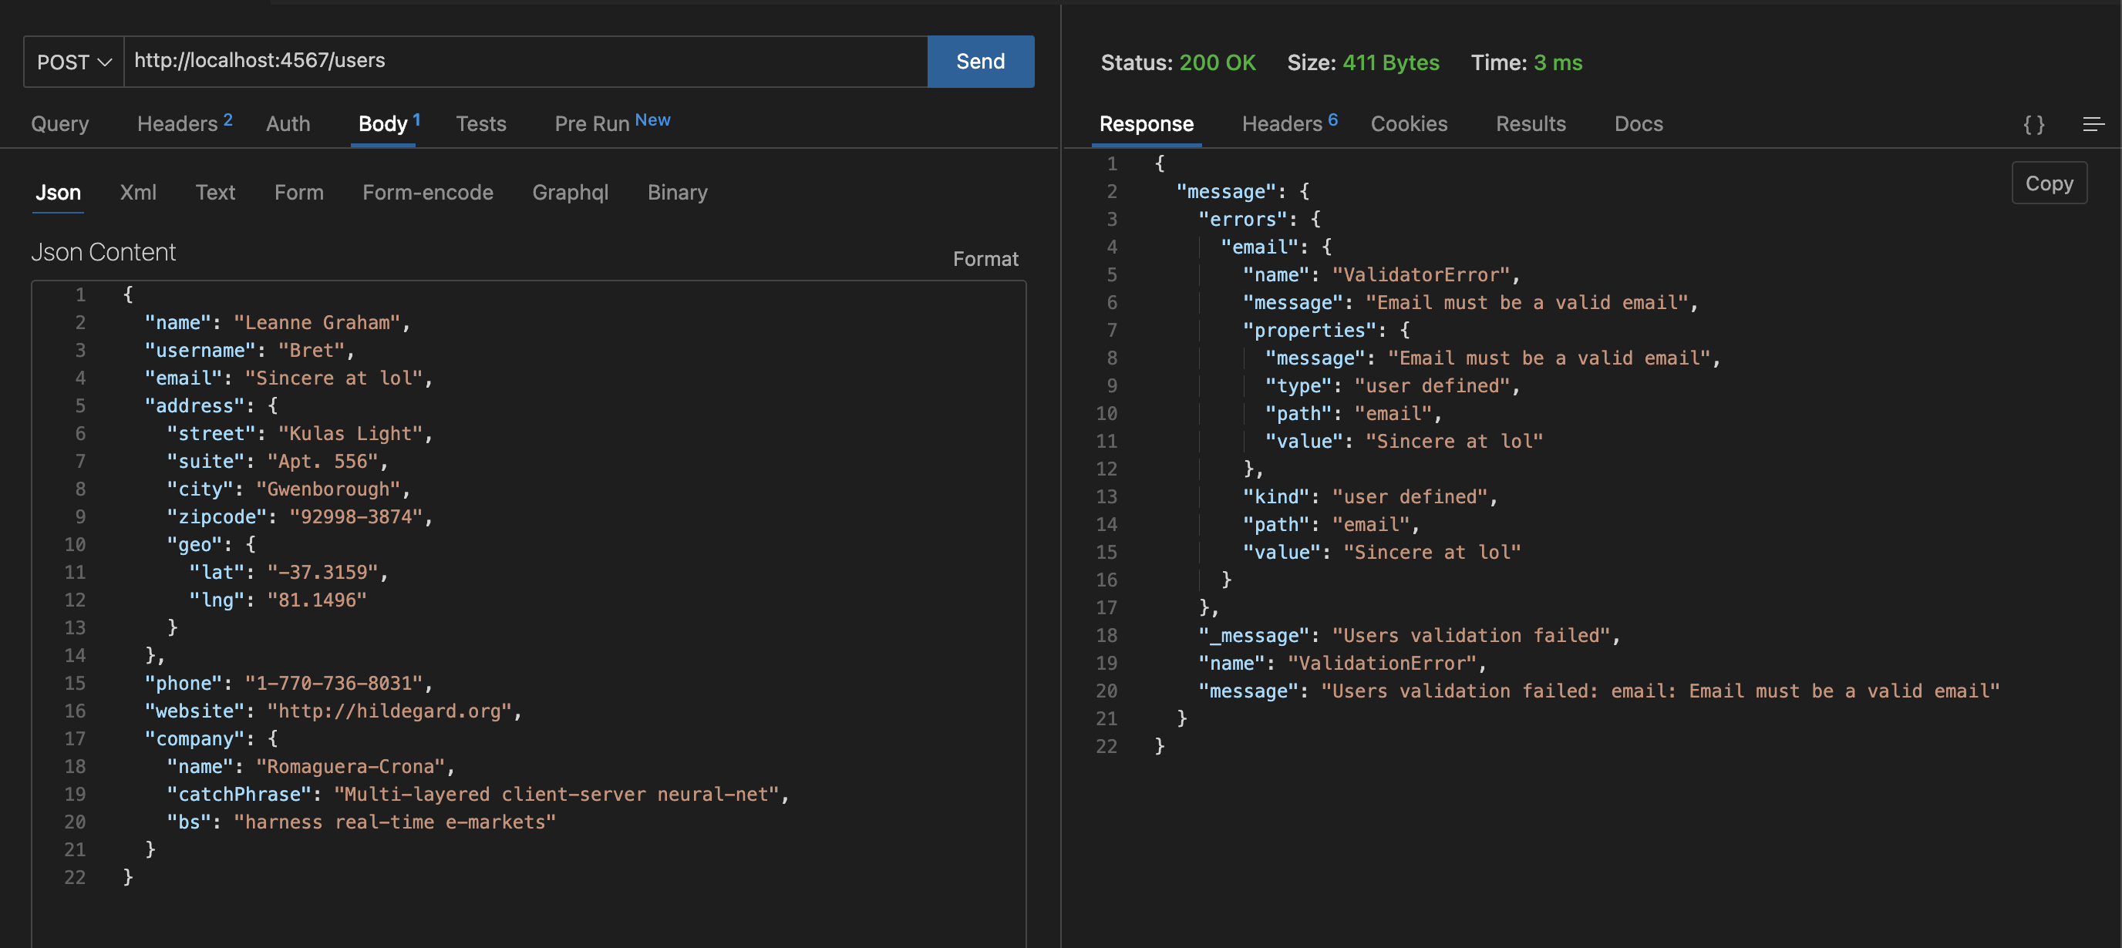

* 1. Allow only alphabets and space while entering **city** name

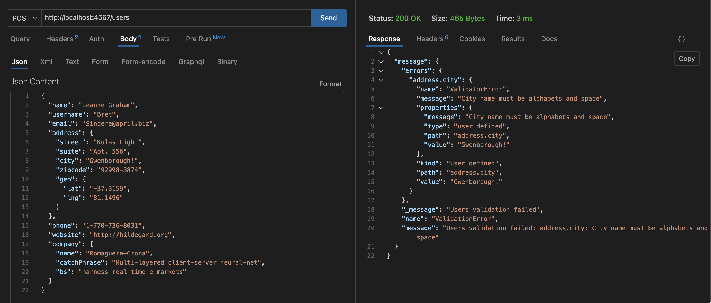

* 1. Allow only valid **web** URL address (**http** or **https** is valid)

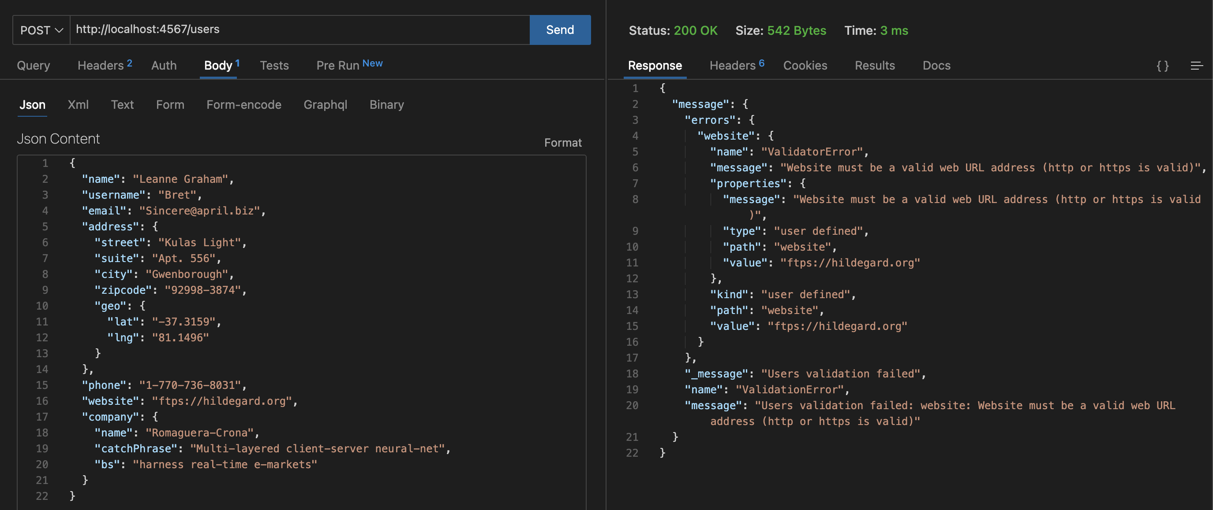

* 1. **Zip** code format must be like 12345-1234 (DDDDD-DDDD, **D = digit**)

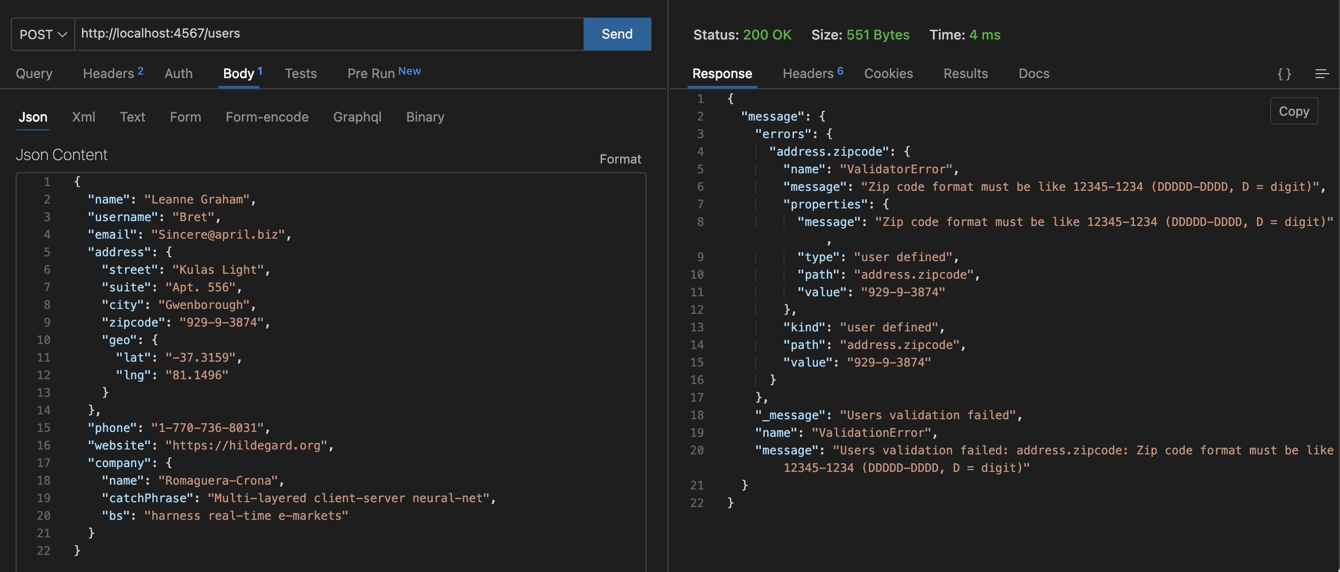

* 1. Validate **phone** format like 1-123-123-1234 (D-DDD-DDD-DDD, **D = digit**)

